

American International University-Bangladesh (AIUB)
Department of Computer Science
Faculty of Science & Technology (FST)

PROJECT TITLE
DoorBell – A Smart Local Service Management Application
Semester: Spring 25-26

Group: |  | Section:
SL | Student Name | Student ID
1 | Md. Najir Ahmmed | 23-53499-3
2 | Sazin Ahmed | 23-53308-3
3 | MD. Mahmudul Hasan | 23-53483-3
4 | Shahed Bhuiyan Rony | 24-56776-1
5

Table of Contents

1. Project Proposal xx
1.1 Background to the Problem xx
1.2 Selection of Process Model xx
2. Timeline Chart / Gantt Chart ………………………….………………………………………………………………...xx
3. Software Requirements Specification (SRS) / PRD xx
3.1 Scopes and Features xx
3.2 User Story Table xx
3.3 Requirements Traceability Matrix xx
3.3.1 Functional Requirements xx
3.3.2 Non-Functional Requirements xx
4. Software Design xx
4.1 System Deisgn xx
4.2 UI Deisgn using Figma xx
5. Git Workflow xx
6. Software Testing xx
7. Conclusion xx

1. PROJECT PROPOSAL
DoorBell – A Smart Local Service Management Application
  - Background to the Problem
Finding reliable home service providers is a common problem. People often need services such as house cleaning, gardening, plumbing, or electrical repair, but they usually do not know whom to contact. They depend on friends’ suggestions or online searches, which can be time-consuming and unreliable. In many cases, the service quality is poor or the workers are not trustworthy.

Service workers also face difficulties. Skilled cleaners, electricians, and gardeners often struggle to find enough customers. Managing schedules, keeping track of bookings, and handling payments manually can be confusing and inefficient. At the same time, service managers find it difficult to monitor workers, customer bookings, and payments using traditional methods.

To address these issues, this project proposes DoorBell, a centralized home service management system. DoorBell is a computer-based platform that connects customers with trusted local service workers. It allows users to book services, schedule appointments, make secure payments, and view service reviews in one place. The system also helps workers manage their assigned jobs and assists managers in organizing services, users, and transactions efficiently.
To solve these problems, the proposed system DoorBell provides a centralized and digital platform that connects customers, service workers, and administrators in one place. Through DoorBell, customers can easily find trusted service providers, book services, schedule appointments, make secure online payments, and view reviews before making decisions.
At the same time, service workers can manage their jobs efficiently by viewing assigned tasks, updating their availability, and organizing their schedules without confusion. The system also supports administrators by allowing them to monitor workers, manage bookings, track payments, and ensure service quality.
Overall, DoorBell reduces the limitations of manual processes, improves efficiency, increases transparency, and creates a reliable and user-friendly environment for home service management.
Who Will Use DoorBell?
1. Customer These are people who need someone to clean their house, fix a leak, or take care of their garden. They are busy and want to find a good worker quickly without stress.
- They want to book a service easily.
- They want to know the worker is trusted and skilled.
- They want to pay safely online.
- They want to read reviews from other customers.

2. Employee These are the cleaners, gardeners, electricians, and plumbers who do the work. They want to find more customers and keep their work organized.
- They need to see their job list for the day or week.
- They want to know the customer's address and details.
- They need to manage their schedule.
- They want a simple way to update their profile and availability.

3. Admin This is the admin person who makes sure DoorBell runs smoothly. They manage everyone and everything on the platform.
- They add or remove workers and services.
- They look at all bookings and payments.
- They solve problems if something goes wrong.
- They make sure the quality of service is good and customers are happy.

DoorBell helps all three groups work together smoothly, making home services simple and trustworthy for everyone.
  - Selection of Process Model
- Process Model Selection (Scrum)
The Scrum framework is used for this project as it has several features and roles for the users, and there might be changes while carrying out the development process. It is an agile technique that allows frequent improvements and changes as it has short sprints that ensure effective delivery within an academic team setup.
- Reason for Using the Scrum Model
The Scrum pattern has been selected for the DoorBell project because it allows the complex system to be developed in a structured and flexible manner. The DoorBell system comprises a number of functionalities like user registration/login, service booking, payment handling, profile management, review systems, and admin panels. It is a difficult task to implement all functionalities simultaneously. Scrum allows the whole process to be divided into smaller tasks referred to as sprints, which allows the entire process to be more organized.
The project also consists of various user roles, which include general users, service providers (employees), and an admin. Each role consists of diverse requirements and features. Scrum facilitates prioritizing the requirements in a product backlog and then executing them one by one, which is a wise way to manage features for various roles and ensure that users receive the right functionalities.
Another key reason why Scrum should be considered in projects involves change in project requirements that can occur while development takes place. This applies in academic projects where changed requirements based on evaluations from lecturers or project supervisors are needed, and Scrum allows this without any impact due to previously accomplished work.
Apart from increasing efficiency, Scrum enhances team working and collaboration. Since the project will be developed by a team within a short semester period, the application of Scrum will enable the team to break down their duties effectively. In every sprint, the team will deliver a functioning version of the system, allowing the team to identify mistakes promptly. With this understanding, the Scrum model is efficient for the application in the DoorBell project.

2. Timeline Chart / Gantt Chart
Task:Person | WEEK 1 | WEEK 2 | WEEK 3 | WEEK 4 | WEEK 5 | WEEK 6
A:NAJIR
B:NAJIR
C:SHAHED
D: SAZIN
E:SAZIN
F:MAHMUDUDL
G:SHAHED
F:MAHMUDUDL

3. SOFTWARE REQUIREMENTS SPECIFICATIONS (SRS) / PRODUCT REQUIREMENTS DOCUMENT (PRD)
Template Name | DoorBell – A Smart Local Service Management Application
Goals & Objective | It offers three main types of services: gardening, cleaning, and electrical services. The system connects users, employees, and the admin on one platform to ensure smooth service management and communication.  From this website user/miner can :  • Easy-to-use interface for quick service booking.  • Access to trusted local service providers near you.  • Multiple service categories like Cleaning, Gardening & Electric.  • Real-time booking and schedule management system.  • Secure and hassle-free payment process.  • User rating and review system for quality assurance.  • Simple admin panel to manage services, users and bookings.
Client Information
Product Type | Web Application
Domain
Access Layers | User, admin,Employee
Design Required | Yes

Phase | Item No | Specification [Role] | Screen Definition | User Story | Acceptance Criteria | UI Screen / Wireframe | Tags
Feature: 1 |  | Auth Feature
phase 1 | 1 | Signup [admin] [User] [Employee] |  |  | - Email (input) field should only accept valid unregistered email address as input, otherwise will show an 'email already used' message.  - Password (input) should be minimum 8 characters long. Otherwise show an invalid message.  - Re-password (input) should match password. Otherwise show 'password do not match' message.  - User type must be selected. Otherwise show 'Please select a user type'.  - On clicking signup button, credential will be stored in database, user will be redirected to his dashboard.  - A copy of the login information will be sent to his email.
phase 1 | 2 | Signin [admin] [User] [Employee] |  |  | - Email must match database email  - password must match database password  - User go to dashboard (if email & password match with database)  - User is promt with an error. "Email or password does not match!". (if email & password match with database)  - clicking signup should take user to signup page  - clicking forgot password should take him to forgot password page
phase 1 | 3 | Forgot password[admin] [User] [Employee] |  |  | - email must match DB email or promt "No email found!"  - pressing send code will print a message "code sent!" and the code can be found at user info row.  - enter new password [At least 8 characters long, atleast one special character]  - re-type new password [it should match new password]  - clicking submit button will show user -> "password changed" if all info match criteria or it'll indicate what's wrong
Feature: 2 |  | Dashboard
phase 1 | 4 | Menu [User] |  |  | Services: View all available service categories.  My Bookings: Check all your service bookings.  Profile (Name Button): View your profile.  Log Out: Sign out from the system.
phase 1 | 5 | Menu[admin] |  |  | Services: View all available service categories.  User Table: Manage and view registered users.  Service Table: View and update service records.  Transactions: See all payment and transaction logs.  My Bookings: Check all your service bookings.  Cleaning Service: Open cleaning service details and booking.  Gardening Service: Open gardening service details and booking.  Electric Service: Open electric service details and booking.  Profile (Name Button): View your profile.  Log Out: Sign out from the system.
 |  | Menu [employee] |  |  | Services: View all available service categories.  Work List: Check all your work list  My Bookings: Check all your service bookings.  Profile (Name Button): View your profile.  Log Out: Sign out from the system.
Feature: 3 |  | Bars
phase 1 | 8 | side Bars |  |  | Services: View all available service categories.  User Table: Manage and view registered users.  Service Table: View and update service records.  Transactions: See all payment and transaction logs.  My Bookings: Check all your service bookings.  Cleaning Service: Open cleaning service details and booking.  Gardening Service: Open gardening service details and booking.  Electric Service: Open electric service details and booking.  Profile (Name Button): View your profile.  Log Out: Sign out from the system.
 |  | top Button |  |  | The “All Services” button must be clearly visible on the dashboard/home screen.  Clicking the button must open the full list of available service categories.  The service list must include all categories (e.g., Cleaning, Gardening, Electrical, Plumbing, etc.).  Each service category must display with its name and icon/image (if available).  The list must load quickly without errors or blank items.  Each service category must be clickable and open its corresponding service details page.  If no services exist, the system must show a “No services available” message.  The button must work for all roles (User, Admin, Employee) based on their permission level.  The layout must be responsive and display correctly on mobile and desktop.  Returning from the service details must bring the user back to the service list.
Feature: 4 |  | Payment
phase 1 | 7 | Payment Details |  |  | The system must display the full service cost breakdown clearly.  User must enter a valid email address before continuing.  User must enter a valid phone number before continuing.  The payment information must match the selected service details.  The screen must update the payment amount correctly if service changes.  User cannot proceed without completing all required fields.
phase 1 | 8 | Payment methods |  |  | The system must show all available payment methods (Card, Mobile Banking, Cash, etc.).  The user must be able to select only one payment method.  The selected payment method must be highlighted or marked as chosen.  The system must verify the chosen method before processing payment.  If payment is successful, a confirmation message must appear.  If payment fails, a clear error message must be shown.  The payment process must be secure and error-free.
Feature: 5 |  | Profile
phase 1 | 9 | View Profile[admi] [empolyee] [user] |  |  | - No null values  - Edit button should take to edit page
phase 1 | 10 | Edit Profile[admi] [empolyee] [user] |  |  | - No null values  - email should be in correct format [xyz@abc.com]  - phone number should be in correct format [11 digits]  - date of birth should be in at least 15 years  - clicking save button will either promt with an error if above rules do not meet or a promt notifying the user about successful change
phase 1 | 11 | Change Profile Photo[admi] [empolyee] [user] |  |  | - current image/ default image is shown  - input file should be an image and not any other format [png,jpg format]  - cofirm button should redirect user to view profile page
phase 1 | 12 | Change Password[admi] [empolyee] [user] |  |  | - user can type current password [it should match database password]  - Password (input) should be minimum 8 characters long. Otherwise show an invalid message.  - Re-password (input) should match password. Otherwise show 'password do not match' message.  - On clicking signup button, credential will be stored in database, user will be prompted with a message. [sucessfully changed / something went wrong]

  - Scopes and Features
The DoorBell – Home Service Management System is a web-based platform designed to digitalize and streamline the connection between homeowners and trusted local service providers. The project aims to replace inefficient, manual methods of finding and booking services with a secure, user-friendly, and role-based system. It enhances accessibility, ensures service quality, and brings transparency to scheduling, payments, and reviews.
This system will serve three primary user roles: Admin, Employee (Service Provider), and Customer (Homeowner). It will support end-to-end operations including service discovery, online booking, automated scheduling, secure payment processing, and centralized management.

Key Features:
The system’s functionality is divided based on user roles. The key features for each role are outlined below.
1) Admin Features:
The Admin is the system supervisor with the highest level of access, responsible for overall platform management, user oversight, and system configuration.
Key functionalities:
- Login securely using admin credentials.
- Manage all user accounts (Customers and Employees)—create, view, update, and delete.
- Manage the service catalogue—add, update, search, and delete services (e.g., Cleaning, Gardening).
- View and monitor all bookings and transactions in real-time.
- Generate and export transaction reports to Excel/PDF.
- Update personal admin profile (username and role are unchangeable).
- Configure system settings (service categories, business hours, payment methods).
- View all customer ratings and reviews.
- Handle and resolve reported issues or disputes.
- Search transactions and bookings by date, user, or service type.
- Log out users remotely if necessary.
- Ensure data consistency and system performance.
2) Employee (Service Provider) Features:
The Employee is a verified service professional (e.g., cleaner, electrician, gardener) who uses the platform to receive job assignments and manage their work.
Key functionalities:
- Login securely with employee credentials.
- View a personalized dashboard with upcoming and assigned jobs.
- See detailed job information, including customer details, service address, and special instructions.
- Update job status (e.g., Accepted, On the way, Completed).
- View personal work history and completed services.
- Update personal profile, including contact information, skills, and availability.
- Change account password securely.
- Upload or change a profile picture.
- Access a list of all available service categories.
- Receive notifications for new job assignments.
3) Customer (Homeowner) Features:
The Customer is a homeowner seeking reliable home services. They interact with the platform to find, book, and pay for services.
Key functionalities:
- Register an account and login securely.
- Browse and search for services by category (Cleaning, Gardening, Plumbing, Electrical, etc.).
- View detailed service descriptions, pricing, and available service providers.
- Book a service by selecting a date, time, and preferred provider.
- Choose from secure online payment methods.
- View a detailed breakdown of costs before confirming payment.
- Track the status of current and past bookings.
- View and download payment receipts.
- Update personal profile information (name, email, phone, address).
- Change account password and profile picture.
- Provide ratings and reviews for completed services.
- Log out of the system securely.

3.2 User Story Table
As A/An | I want to | So that | Acceptance Criteria
admin | As a new user  I want to create an account  using phone/email | So that I can  access the  service platform. | Signup must verify a valid and unused email, ensure the  password is at least eight  characters and matches the re- entered password, and require selecting a user type. On successful signup, the user is saved in the database,  redirected to the dashboard, and  sent a confirmation email.
 | As a registered user  I want to log in securely with my credentials | So that I can access my dashboard. | Sign in must confirm that the email and password match the database; otherwise, an error message appears. Users must be able to navigate to signup and password recovery pages from here.
 | I want to reset my forgotten password | So that I can  recover access | The system must confirm the email exists, send a reset code, and require a valid new  password and matching confirmation. If valid, the  password updates successfully; otherwise, clear error messages  appear.
 | I want to  manage all system  information | So that I can control services, users, and business data. | The admin menu must correctly open service modules, user  tables, service tables,  transactions, bookings, and profile options.
 | I want to view my stored  information | So that I can verify and manage my  account | The profile page must show all user data without blanks and  allow navigation to edit profile
 | I want to update my personal  info | So that my profile stays accurate. | Editing must validate email  format, phone number, and age, then save changes or show errors.
 | I want to change my profile picture | So that I can  personalize my account. | Users may upload only PNG/JPG images, and after confirming, the system must show the  updated photo.
 | I want to change my password | So that I can keep my account secure. | The system must verify the current password, validate the new one, and update it or show an error.
 | View Service Table | I can update existing services | Table with update/edit options
 | View Transactions | I can track all payments | Transaction list displayed with filters
 | Log out | I can exit the  system securely | Redirects to login screen
 | View payment breakdown (when needed) | I can confirm cost structure | Shows full cost breakdown clearly
reemploy | As a new user  I want to create an account  using phone/email | So that I can  access the  service platform. | Signup must verify a valid and unused email, ensure the  password is at least eight  characters and matches the re- entered password, and require selecting a user type. On successful signup, the user is saved in the database,  redirected to the dashboard, and sent a confirmation email.
 | As a registered user  I want to log in securely with my credentials | So that I can access my dashboard. | Sign in must confirm that the email and password match the database; otherwise, an error message appears. Users must be able to navigate to signup and password recovery pages from here.
 | I want to reset my forgotten password | So that I can  recover access | The system must confirm the email exists, send a reset code, and require a valid new  password and matching confirmation. If valid, the  password updates successfully; otherwise, clear error messages appear.
 | I want to  manage all system  information | So that I can  complete tasks and track work. | The dashboard must show service lists, work lists,  bookings, profile, and logout, all functioning properly.
 | I want to view my stored  information | So that I can verify and manage my  account | The profile page must show all user data without blanks and  allow navigation to edit profile.
 | I want to update my personal  info | So that my profile stays accurate. | Editing must validate email  format, phone number, and age, then save changes or show errors.
 | I want to change my profile picture | So that I can  personalize my account. | Users may upload only PNG/JPG images, and after confirming, the system must show the  updated photo.

 | Use “All Servicesˮ button | I can see available service categories | Displays all categories with icons
 | View service details | I can prepare for the work | Shows customer info & location
 | View work list | I can track tasks | Shows all assigned bookings
 | View my bookings | I can review my completed services | Booking list with status
User | As a new user  I want to create an account  using phone/email | So that I can  access the  service platform. | Signup must verify a valid and unused email, ensure the  password is at least eight  characters and matches the re- entered password, and require selecting a user type. On successful signup, the user is saved in the database,  redirected to the dashboard, and sent a confirmation email.
 | As a registered user  I want to log in securely with my credentials | So that I can access my dashboard. | Sign in must confirm that the email and password match the database; otherwise, an error message appears. Users must be able to navigate to signup and password recovery pages from here.
 | I want to reset my forgotten password | So that I can  recover access | The system must confirm the email exists, send a reset code, and require a valid new  password and matching confirmation. If valid, the  password updates successfully; otherwise, clear error messages appear.
 | I want to see a clean menu of services  (Gardening, Cleaning,  Plumbing) | So that I can  control services,  users, and business data. | The dashboard must show service categories, bookings, profile access, and logout, with all options linking correctly.
 | I want to view my stored  information | So that I can verify and manage my  account | The profile page must show all user data without blanks and  allow navigation to edit profile.
 | I want to update my personal  info | So that my profile stays accurate. | Editing must validate email  format, phone number, and age, then save changes or show errors.
 | I want to change my profile picture | So that I can  personalize my account. | Users may upload only PNG/JPG images, and after confirming, the system must show the  updated photo.
 | I want to change my password | So that I can keep my account secure. | The system must verify the current password, validate the new one, and update it or show an error.
 | View clean service menu | I can quickly choose a service | Shows Gardening, Cleaning, Electrical
 | View specific service details | I understand what Iʼm booking | Shows details, pricing, available employees
 | Log out | I can exit safely | Redirect to login
 | Choose payment method | I can complete booking | Must select one method; success/failure message
 | Make secure payment | My booking becomes confirmed | payment success → “Paidˮ; failure → error shown

3.3.1 Functional Requirements

Functional Requirement | Example Scenario
The system shall allow users to register using email/phone and password. | A new user opens the DoorBell application and creates an account by entering their email address or phone number along with a secure password. The system validates the input and successfully registers the user.
The system shall allow users to log in securely. | A registered user enters their credentials (email/phone and password) into the login page. The system verifies the details and grants access to the dashboard upon successful authentication
The system shall allow users to reset their password via email | When a user forgets their password, they request a password reset. The system sends a time-limited reset link to the registered email, allowing the user to securely create a new password.
The system shall allow users to browse service categories. | A user navigates through the application and views available service categories such as plumbing, electrical repair, cleaning, and other home services with descriptions.
The system shall allow users to view service details | A user selects a service category and views detailed information including service description, estimated price range, and available service providers in their area.
The system shall allow users to book a service with date and time. | A user selects a service provider and schedules a service appointment by choosing a preferred date and time slot according to availability.
The system shall allow users to choose payment method. | During checkout, the user selects a payment method such as cash on delivery or digital payment options before confirming the booking.
The system shall allow users to view booking history. | A user accesses their profile to view a complete list of past and upcoming service bookings along with their status updates.
The system shall allow users to update profile information. | A user updates personal details such as phone number, home address, or profile picture from the account settings page.
The system shall allow users to change password. | A user changes their account password by entering the current password and setting a new secure password for improved account safety.
The system shall allow users to log out securely. | A user logs out of the system, and their session is terminated to ensure that no unauthorized access occurs afterward.
The system shall allow users to log out securely. | A user logs out of the system, and their session is terminated to ensure that no unauthorized access occurs afterward
The system shall allow employees to view assigned jobs. | A service provider logs into the system and views a list of assigned service requests that they need to complete.
The system shall allow employees to view job details | An employee opens a job request to view detailed information such as customer location, service type, and instructions.
The system shall allow admin to manage users. | An admin accesses the management panel to view all registered users and performs actions such as editing or deleting accounts if necessary
The system shall allow admin to manage services. | An admin adds new service categories or updates existing ones such as plumbing, cleaning, or electrical services in the system.
The system shall allow admin to view transactions. | An admin monitors all financial transactions and booking records to ensure system activity is properly tracked.

3.3.2 Non-Functional Requirements
Type | Requirement
Performance | The system shall ensure that course listings and user dashboards are displayed within 3 seconds under normal network conditions.
Performance | The system shall be capable of handling at least 100 simultaneous users without any significant performance drop.
Availability | The system shall maintain 99.5% operational uptime and be accessible 24/7, excluding planned maintenance periods.
Security | The system shall store user passwords using secure hashing methods to ensure data protection.
Security | Access to the dashboard shall be restricted to authenticated users, and user sessions shall automatically terminate after 30 minutes of inactivity.
Scalability | The system shall handle up to 500 registered users and 50 active courses in its initial phase, with easy upgrade paths.
Reliability | The system shall prevent data loss during unexpected shutdowns by auto-saving critical user actions.
Usability | A new user shall be able to complete registration and enroll in a course within 2 minutes without external help.
Usability | The interface shall be responsive and work smoothly on desktops, tablets, and mobile devices.

4. SOFTWARE DESIGN
4.1 System Design:
Use Case Diagram:
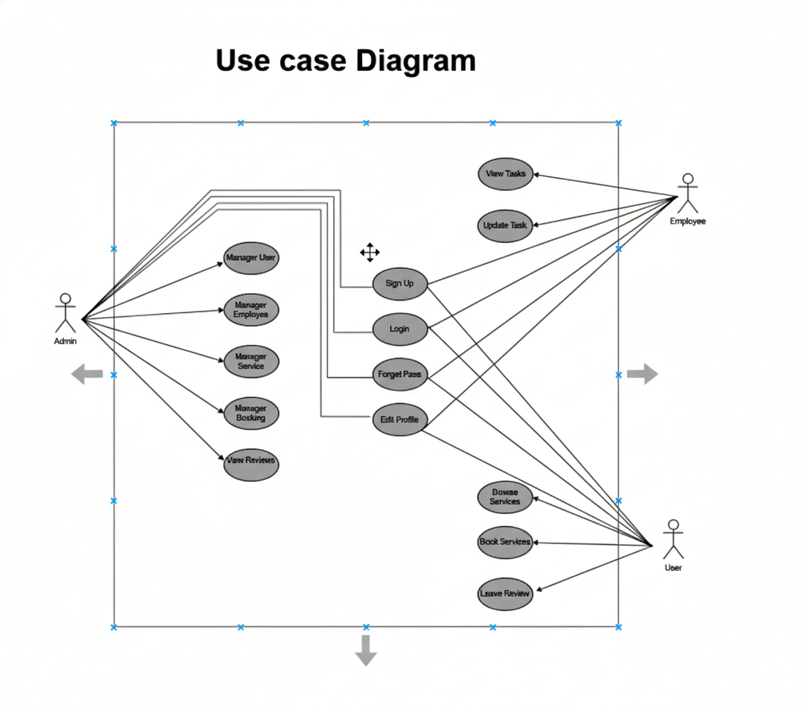
Fig: Use Case Diagram

Class Diagram:

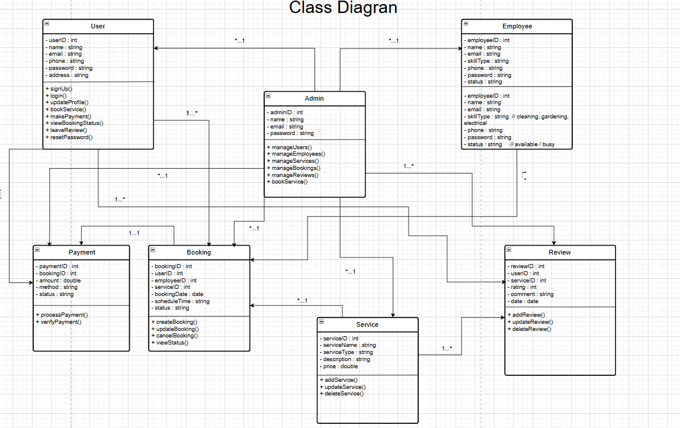
Fig: Class Diagram

UI / Wireframe Design using Figma
Shahed Bhuiyan Rony
Login
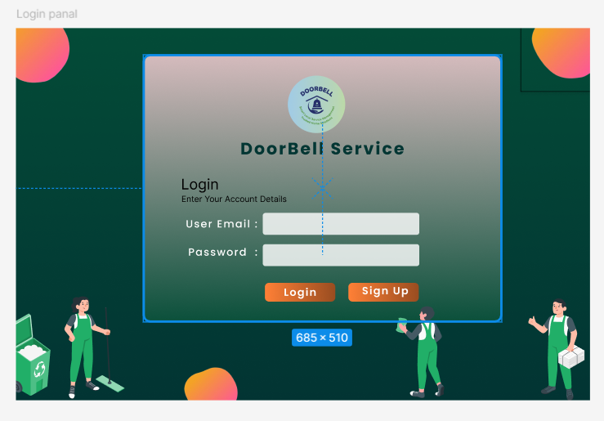
Sign Up
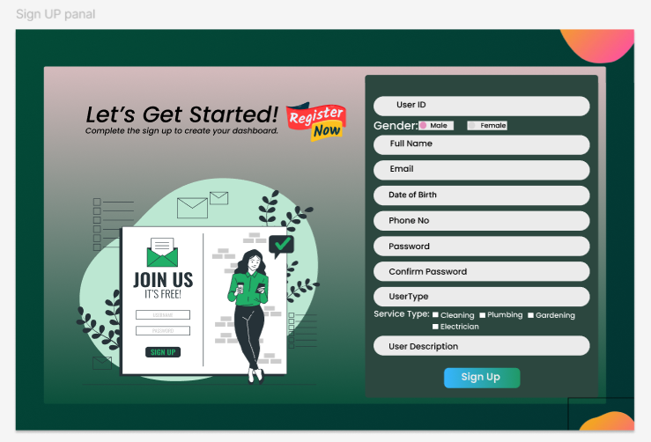

Shahed Bhuiyan Rony

Home
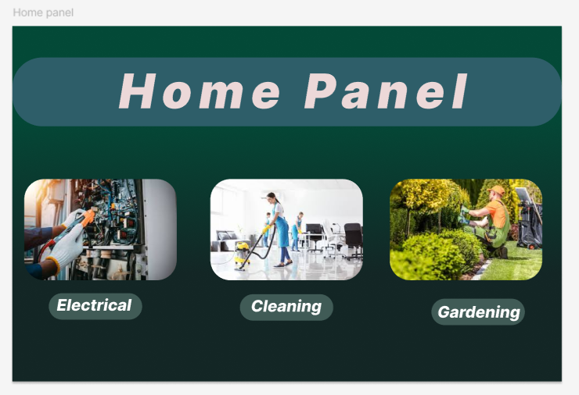
Profile
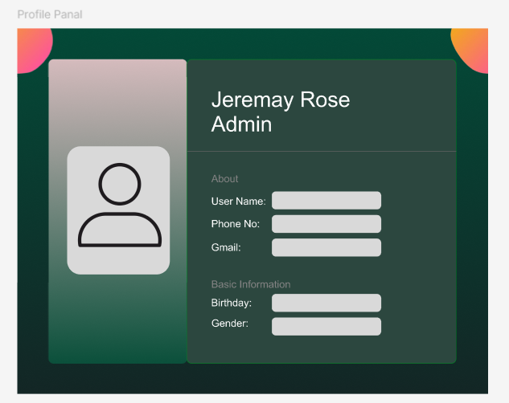

Md. Najir Ahmmed
Payment
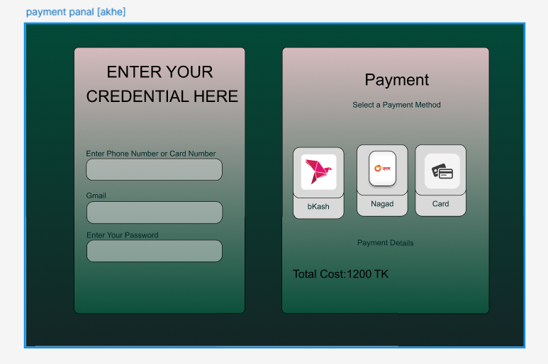
Forgot
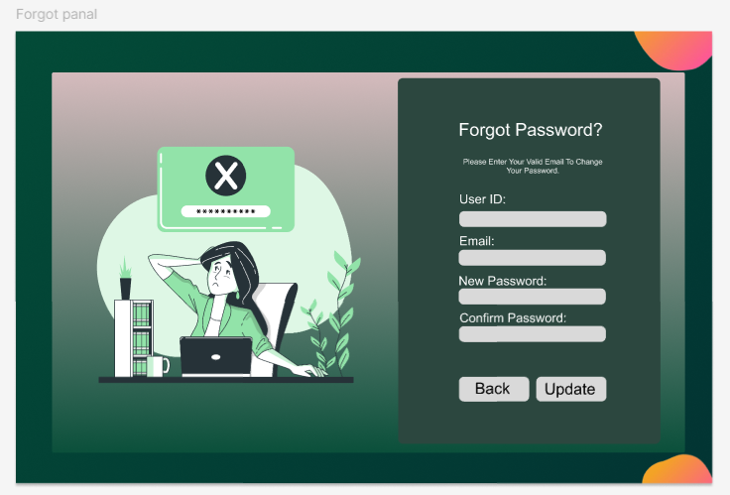
Sazin Ahmed
Booking
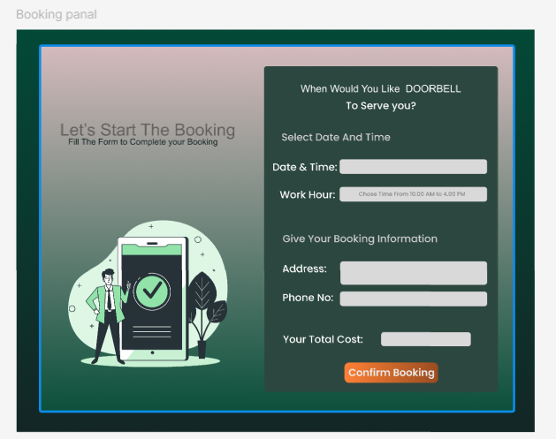

Update 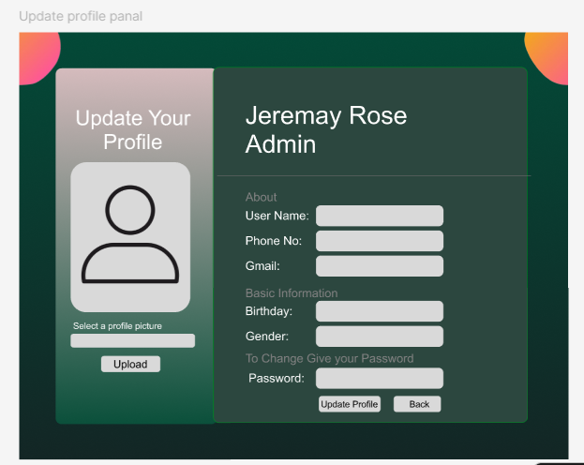
MD. Mahmudul Hasan
Service
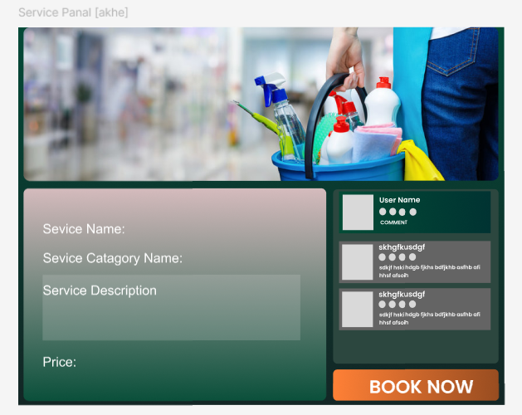

Table 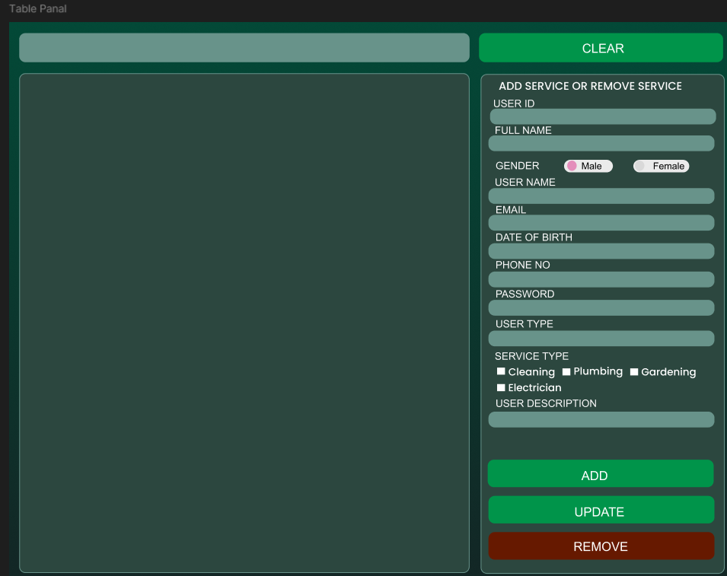

5. GIT WORKFLOW
Link : https://github.com/najirahmed957-stack/project-simulator--team-alpha.git
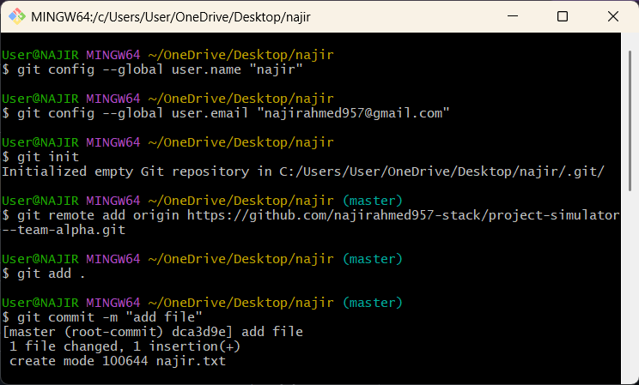
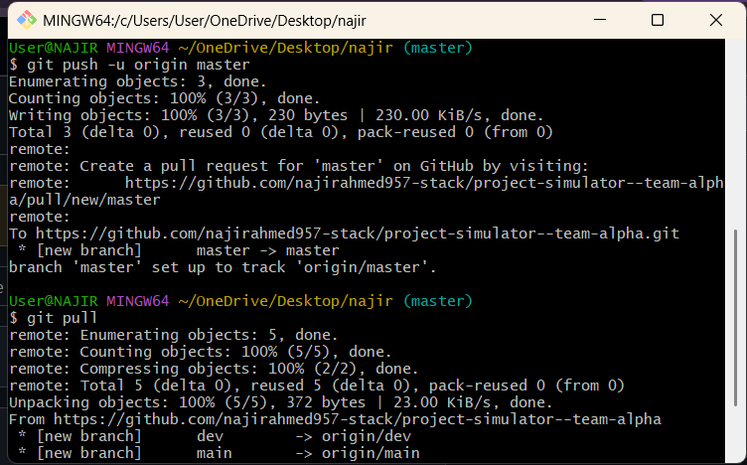


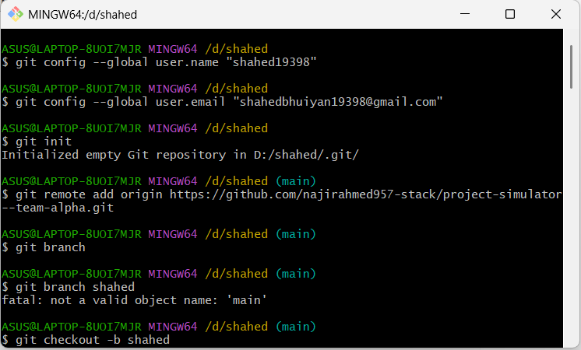
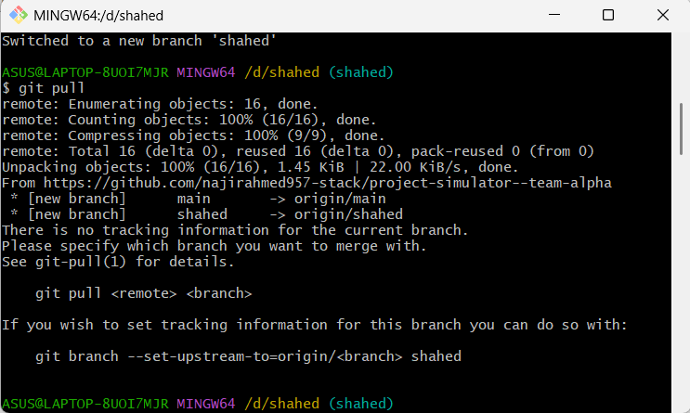
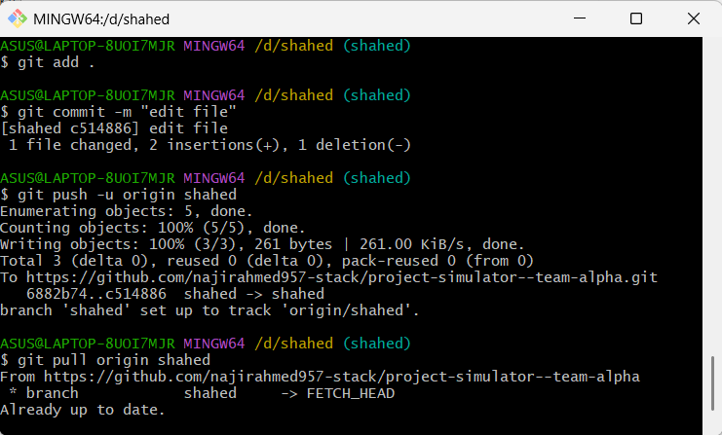
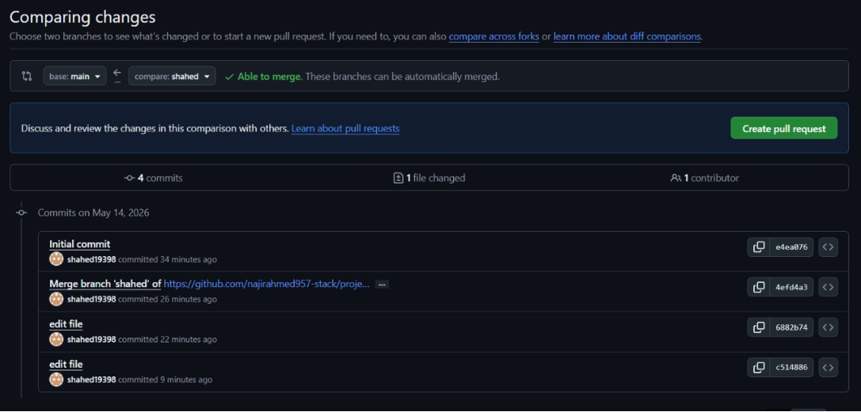

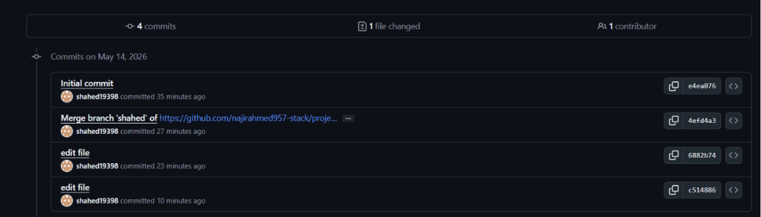

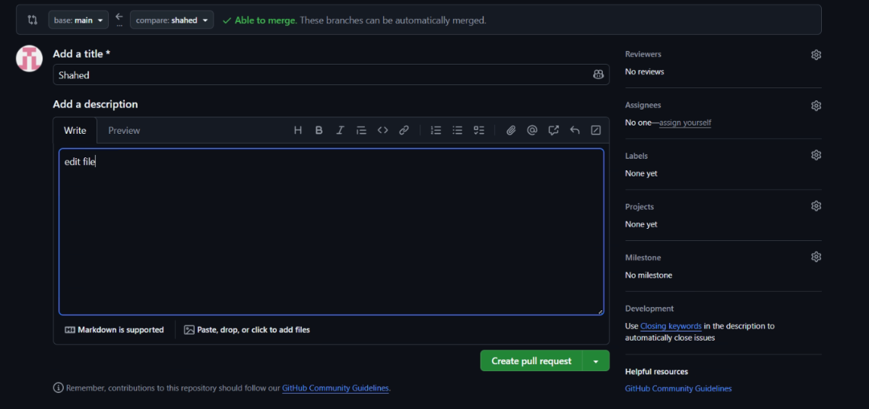

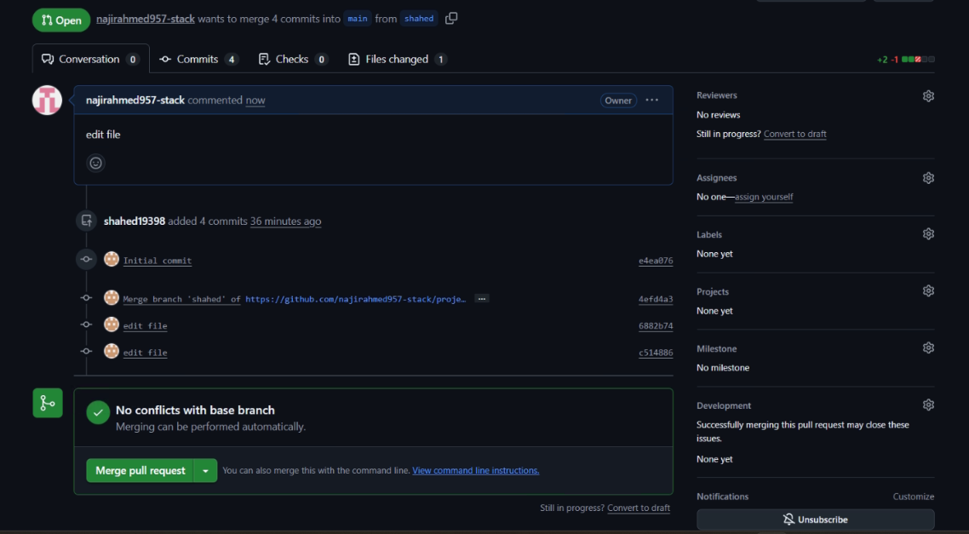

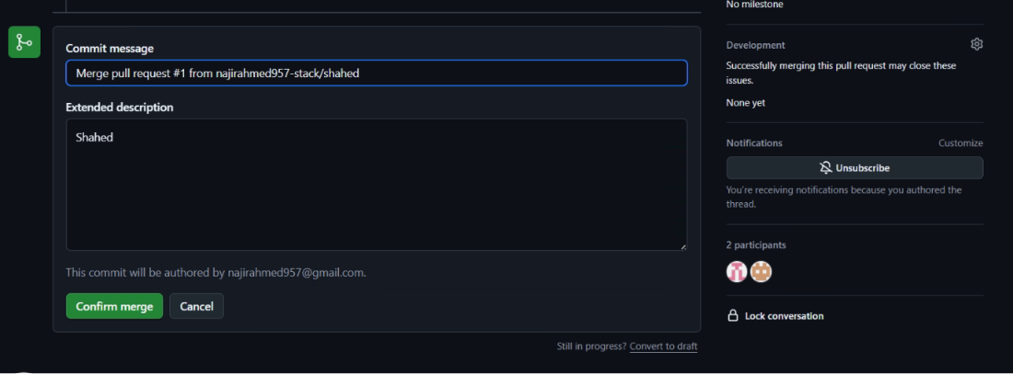

6. SOFTWARE TESTING
Project Name: Doorbell |  |  | Test Designed by: Md.Najir Ammeed
Test Case ID:TC_01 |  |  | Test Designed date:24/04/2026
Test Priority (Low, Medium, High): Medium |  |  | Test Executed by: Md.Najir Ammeed
Module Name: Reset Password |  |  | Test Execution date: 29/04/2026
Test Title: Verify login with valid username and password
Description: Test the password reset functionality
Precondition: User has forgotten their password
Dependencies: if any
Test Steps | Test Data | Expected Results |  | Actual Results | Status (Pass/Fail)
- Go to the password reset page.  - Enter the registered email  Address.  - Click on reset password.  - Check email for reset link.  - Enter new password. | Email: najir@gmail.  com.  New Password: new1234. | User should see the reset instructions.  Password should be reset successfully. |  | As expected. | Pass.

Project Name: Doorbell |  |  | Test Designed by: Md.Najir Ammeed
Test Case ID:TC_02 |  |  | Test Designed date:24/04/2026
Test Priority (Low, Medium, High): Medium |  |  | Test Executed by: Md. Najir Ahmmed
Module Name: Sidebar |  |  | Test Execution date: 29/04/2026
Test Title: Verify sidebar navigation links are working properly
Description: Test the sidebar navigation functionality to ensure all sidebar menu options redirect to the correct pages
Precondition: User must be logged into the system successfully.
Dependencies: if any
Test Steps | Test Data | Expected Results |  | Actual Results | Status (Pass/Fail)
- Open the application dashboard.  - Locate the sidebar menu.  - Click on each sidebar option (Home, Profile, Settings, Logout).  - Observe the page navigation. | Home  Profile  Settings  Logout | Sidebar should be visible after login.  Each menu item should redirect to its respective page correctly.  Logout should redirect to the login page. |  | As expected. | Pass.

Project Name: Doorbell |  | - Text designed by : Shahed Bhuiyan Rony
Test case : TC_03 |  | This designed date : 25/04/2026
Test Priority (Low, Medium, High): High |  | Test Executed by : Shahed Bhuiyan Rony
Module Name : User Management / Service Management |  | Test Execution date : 29/04/2026
Test title : Verify User Management panel add, update, remove and service assignment
Description: Test the User Management panel to ensure user data listing, add, update, remove, and service assignment functionalities work correctly.
Precondition: 1. Admin is logged into the DOORBELL system 2. User Management panel is accessible
Dependencies: None
Test Steps | Test Data | Expected Results | Actual Results | Status (Pass/Fail)
1. Open User Management panel | __ | User table should load successfully | As expected | Pass
2. Verify user table columns | User ID, Name, Gender, DOB, Email, Phone, User Type | All columns should be visible | As expected | Pass
3. Select a user from table | U-0004 | Selected user data should populate form fields | As expected | Pass
4. Enter new user details | Valid data | All input fields should accept data | As expected | Pass
5. Select Gender | Male / Female | Only one gender should be selectable | As expected | Pass
6. Select User Type | Admin / User / Cleaner / Plumber etc. | User type should be selected correctly | As expected | Pass
7. Select Service Type | Cleaning, Plumbing | Multiple services should be selectable | As expected | Pass
8. Click ADD button | --- | New user should be added to the table | As expected | Pass
9. Update existing user data | Change phone no | User data should be updated | As expected | Pass
10. Click UPDATE button | ___ | Updated data should reflect in table | As expected | Pass

Project Name: Doorbell |  | Text designed by : Shahed Bhuiyan Rony
Test case : TC_04 |  | This designed date : 25/042026
Test Priority (Low, Medium, High): Medium |  | Test Executed by : Shahed Bhuiyan Rony
Module Name : Service Booking |  | Test Execution date :29/042026
Test title : Verify service booking with valid date, time, and user details
Description: Test the service booking form on the DOORBELL application
Precondition: 1. User is on the booking page. 2. User has selected a service.
Dependencies: None
Test Steps | Test Data | Expected Results | Actual Results | Status (Pass/Fail)
1. Go to booking page | __ | Booking page should load successfully | As expected | Fail
2. Select Date & Time | 24/04/2026  Time: 10:00 AM | Date and time should be accepted | As expected | Fail
3. Select Work Hour | 10:00 AM – 4:00 PM | Work hour should be selected | As expected | Fail
4. Enter Address | Dhaka, Bangladesh | Address should be entered successfully | As expected | Fail
5. Enter Phone No | 01723456778 | Phone number should be accepted | As expected | Fail
6. Verify Total Cost | 1300 BDT | Correct total cost should be displayed | As expected | Fail
7. Click Confirm Booking | __ | Booking should be confirmed and success message shown | As expected | Fail

Project Name: Doorbell |  | Text designed by : Md. Mahmududl Hasan
Test case : TC_05 |  | This designed date : 24/04/2026
Test Priority (Low, Medium, High): Medium |  | Test Executed by : Md. Mahmududl Hasan
Module Name : Home Panel |  | Test Execution date : 29/04/2026
Test title : Verify Home Panel UI and service navigation
Description: Test the Home Panel of the DOORBELL application to verify service categories visibility and navigation.
Precondition: 1.User has successfully opened the DOORBELL application 2. User is logged in (if required)
Dependencies: None
Test Steps | Test Data | Expected Results | Actual Results | Status (Pass/Fail)
1.Open the application | __ | Home panel should load successfully | As expected | Pass
2. Verify Home Panel title | Home Panel | “Home Panel” title should be visible | As expected | Pass
3. Verify Electrical service card |  | Electrical service card should be displayed | As expected | Pass
4. Verify Cleaning service card |  | Cleaning service card should be displayed | As expected | Pass
5. Verify Gardening service card |  | Gardening service card should be displayed | As expected | Pass
6. Click on Electrical service | Electrical | User should be redirected to Electrical service booking page | As expected | Pass
7. Navigate back to Home Panel | __ | Home panel should load again | As expected | Pass
8. Click on Cleaning service | Cleaning | User should be redirected to Cleaning service booking page | As expected | Pass
9. Navigate back to Home Panel |  | Home panel should load again | As expected | Pass
10. Click on Gardening service | Gardening | User should be redirected to Gardening service booking page | As expected | Pass

Project Name: Doorbell |  |  | Test designed by : Md. Mahmududl Hasan
Test case :TC -06 |  |  | This designed date : 24/04/2026
Test Priority (Low, Medium, High): High |  |  | Test Executed by : Md. Mahmududl Hasan
Module Name : User Registration |  |  | Test Execution date : 29/04/2026
Test title : Verify service booking with valid date, time, and user details
Description: Test the user sign-up functionality on the DOORBELL application
Precondition: 1. User is on the registration page. 2. Internet connection is available.
Dependencies: None
Test Steps | Test Data | Expected Results |  | Actual Results | Status (Pass/Fail)
1. Go to Sign Up page | __ | Registration page should load successfully |  | As expected | Pass
2. Enter User ID | Asif23 | User ID should be accepted |  | As expected | Pass
3. Select Gender | Male | Gender option should be selectable |  | As expected | Pass
4. Enter Full Name | Mahmududl Hasan | Full name should be accepted |  | As expected | Pass
5. Enter Email | mahmududl@gmail.com | Valid email should be accepted |  | As expected | Pass
Select Date of Birth | 01/01/2002 | Date of birth should be selected |  | As expected | Pass
7. Enter Phone No | 0171234567 | Phone number should be accepted |  | As expected | Pass
8. Enter Password | 12345 | Password should be masked |  | As expected | Pass
9. Enter Confirm Password | 12345 | Passwords should match |  | As expected | Pass
10. Select User Type | Customer | User type should be selected |  | As expected | Pass
11. Select Service Type | Cleaning | Service type should be selectable |  | As expected | Pass
12. Enter User Description | Home service user | Description should be accepted |  | As expected | Pass

Project Name: Doorbell |  |  | Test Designed by: Sazin Ahmed
Test Case ID:TC_08 |  |  | Test Designed date:24/04/2026
Test Priority (Low, Medium, High): High |  |  | Test Executed by: Sazin Ahmed
Module Name: Dashboard / Services |  |  | Test Execution date: 30/04/2026
Test Title: Verify functionality of “All Services” top button
Description: Test the visibility, functionality, and navigation behavior of the “All Services” button
Precondition: 1. User/Admin/Employee is logged in 2. User is on Dashboard/Home screen
Dependencies: Services must exist in the system (for positive flow)
Test Steps | Test Data | Expected Results |  | Actual Results | Status (Pass/Fail)
1. Open Dashboard/Home screen | — | “All Services” button should be clearly visible |  | As expected | Pass
2. Click on “All Services” button | — | Full list of service categories should open |  | As expected | Pass
3. Verify service categories list | Cleaning, Gardening, Electrical, Plumbing | All available categories should be displayed |  | As expected | Pass
4. Verify service name & icon | — | Each service should show name and icon/image |  | As expected | Pass
5. Check page load behavior | — | Service list should load quickly without errors or blank items |  | As expected | Pass
6. Click on a service category | Cleaning | Selected service details page should open |  | As expected | Pass
7. Navigate back from service details | — | User should return to the service list page |  | As expected | Pass
8. Verify behavior when no services exist | No services in system | “No services available” message should be shown |  | As expected | Pass
9. Verify access for different roles | User, Admin, Employee | Button should work according to role permissions |  | As expected | Pass
10. Verify responsive layout | Mobile & Desktop view | Layout should display correctly on all devices |  | As expected | Pass

Project Name: Doorbell |  |  | Test designed by : Sazin Ahmed
Test case :TC-09 |  |  | This designed date : 24/04/2026
Test Priority (Low, Medium, High): High |  |  | Test Executed by : Sazin Ahmed
Module Name : Update Profile |  |  | Test Execution date : 30/04/2026
Test Title: Verify Update Profile functionality with valid and invalid user information
Description: This test case verifies that a logged-in user can successfully update profile information such as profile picture, username, phone number, email, birthday, gender, and password from the Update Profile page.
Precondition: 1. User must be logged in. 2. User must be on the Update Profile page. 3. Internet connection must be available
Dependencies: None
Test Steps | Test Data | Expected Results |  | Actual Results | Status (Pass/Fail)
1. Open Update Profile page | __ | Update Profile page loads successfully |  | As expected | Pass
2. Select profile picture | Valid image (.jpg/.png) | Profile picture should be selected |  | As expected | Pass
3. Click Upload button | __ | Profile picture should upload |  | As expected | Pass
4. Enter User Name | Sazin Ahmed | User name should be updated |  | As expected | Pass
5. Enter Phone Number | 01747161672 | Phone number should be accepted |  | As expected | Pass
6. Enter Gmail | user2912@gmail.com | Valid email should be accepted |  | As expected | Pass
7. Select Birthday | 0171234567 | Birthday should be selected |  | As expected | Pass
8. Select Gender | Male/Female | Gender should be selectable |  | As expected | Pass
9. Enter Password | ******** | Passwords should match |  | As expected | Pass
10. Click Update Profile button | __ | Profile should be updated successfully |  | As expected | Pass
11. Click Back button | __ | User should be redirected to previous page |  | As expected | Pass

7. CONCLUSION
In this project, we successfully developed the concept and design of a Smart Doorbell Service System that provides three essential home services: Electrical, Cleaning, and Gardening. Through detailed requirement analysis, system design, and careful planning, we created a structured solution that ensures quick service access, organized communication, and improved user convenience. The project demonstrates how everyday household tasks can be simplified through digital automation and proper service management.
We used the Scrum Process Model, which helped our team work in short, manageable sprints. Each sprint allowed us to focus on specific modules, receive feedback, and implement improvements. This iterative approach significantly enhanced team collaboration, productivity, and delivery quality. The modular nature of Scrum also ensured that changes could be made without disrupting the entire development process.
Overall, this project helped us gain practical knowledge of software engineering concepts such as SRS, diagrams, UI design, testing, and Git workflow. It strengthened our understanding of real-life system development and improved our teamwork and communication skills. We believe this Smart Doorbell Service System can be further developed into a fully functional application that will provide convenient and reliable home services to users.

